Q1. Design following html page and clicking print button print value of n1 till n2 along with Equivalent ASII Character below red line. Write validation code in JavaScript where n1 and n2 should be between -128 to +127.

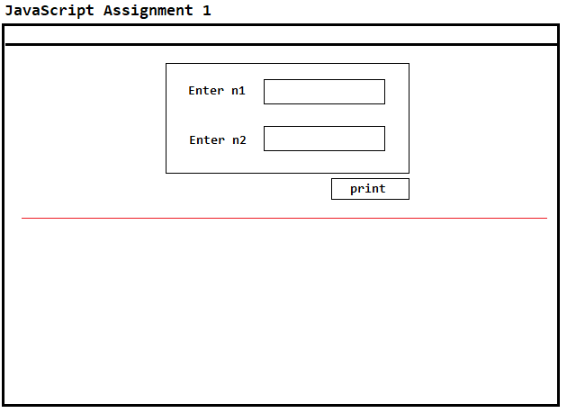

# Q2. Design following html page to dynamically add elements in array “x”. Define JavaScript function in file “assignment-scripts.js” to separate number and string values. Print result on html page

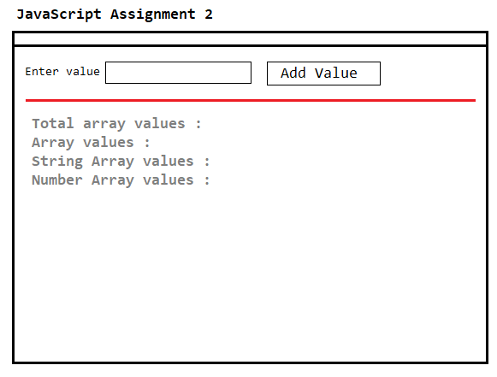

# Q3. Design following Html Page with button “find duplicates”. Write a script using JavaScript and create array of 10 numbers. Check and print duplicate array values below red line

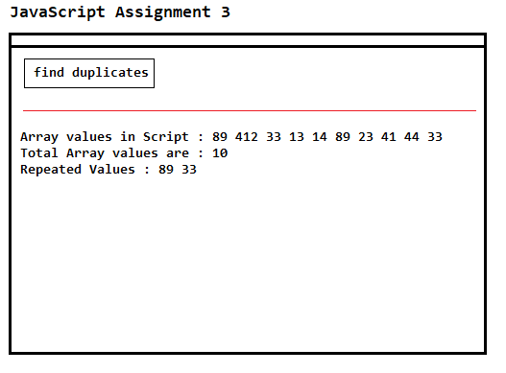

# Q4. Design Html Page and solve following.

# create html dropdown reading name of countries from array dynamically

# create cards on html page showing course data from associative array

**sample script**

<script>

**var countries** = [“India”,”America”,”Austrellia”,”England”]

**var course_data** = {

1:{'course':'BootStrap','descr':'Bootstrap. Build responsive, mobile-first projects on the web with the worlds most popular front-end component library.','img':'bootstrap.png'},

2:{'course':'Java','descr':'Java is Object Oriented programming Language invented in 1991 by James Gosling','img':'java.png'},

3:{'course':'Python','descr':'Python is a widely used general-purpose, high level programming language. It was initially designed by Guido in 1991','img':'python.png'},

4:{'course':'Node Js','descr':'Node.js is an open-source, cross-platform JavaScript run-time environment that executes JavaScript code outside of a browser.','img':'node.png'}

}

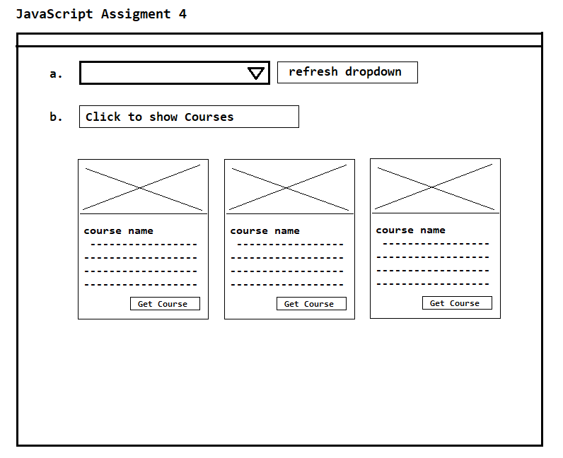</script>